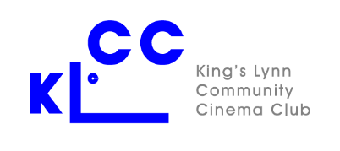

Post film Indian meal Sunday 22nd January 2023
Booking Form
Please e-mail the completed form to annefendley2@gmail.com or bring it to the film on January 12th and hand to Anne Fendley. (Please do not give it to the person signing you into a film).
Please indicate your choice of the meat or vegetarian option for the main course and tell us if you are gluten-free or have another food allergy.
Name(s). Please print Main course choice Any food allergy?
Meat or Vegetarian?
1
2
3
4

Contact details
email:
telephone:

Payment
Please pay at the time of booking either by bank transfer to NatWest Bank, Sort Code 53-61-38, Account Number 66690722, ensuring that your name is in the reference, or by cheque made payable to “Kings Lynn Community Cinema Club”.
Amount paid (£18 per person):
Payment method: Bank Transfer/Cheque. (Delete as appropriate)

