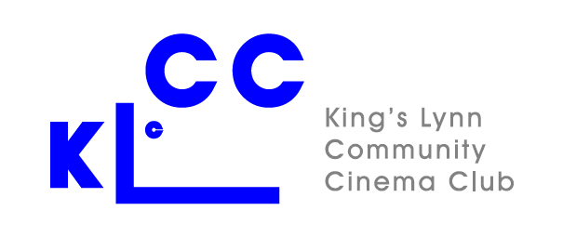
Visit to Well-next-the-Sea Saturday June 25th 2022

Booking form

Please e-mail the completed form to socialevents@klccc.uk or bring it to a film or Close Up event and hand to Pauline Stevens-Smith or Anne Fendley. (Please do not give it to the person signing you in)

Name (s) including up to one non-member per member (If appropriate). Please print.

- Member

2. Member/non-member (Delete as appropriate)

- Member/non-member (Delete as appropriate)

Contact details.

email:

telephone:

Payment.
Please pay at the time of booking either by bank transfer to NatWest Bank, Sort Code 53-61-38, Account Number 66690722, ensuring that your name is in the reference, or by cheque made payable to “Kings Lynn Community Cinema Club”.

Amount paid (£10 per member, £12.00 per non-member).

Payment method: Bank Transfer/Cheque. (Delete as appropriate)

